**SOP for Data Conversion and Preparation of Purity Report**

1. Resave R output datafile GenoResults.csv as excel file
2. Upload R output datafile GenoResults.xlsx into Microsoft Access
3. Use crosstab query MATRIX to transform data into matrix format. 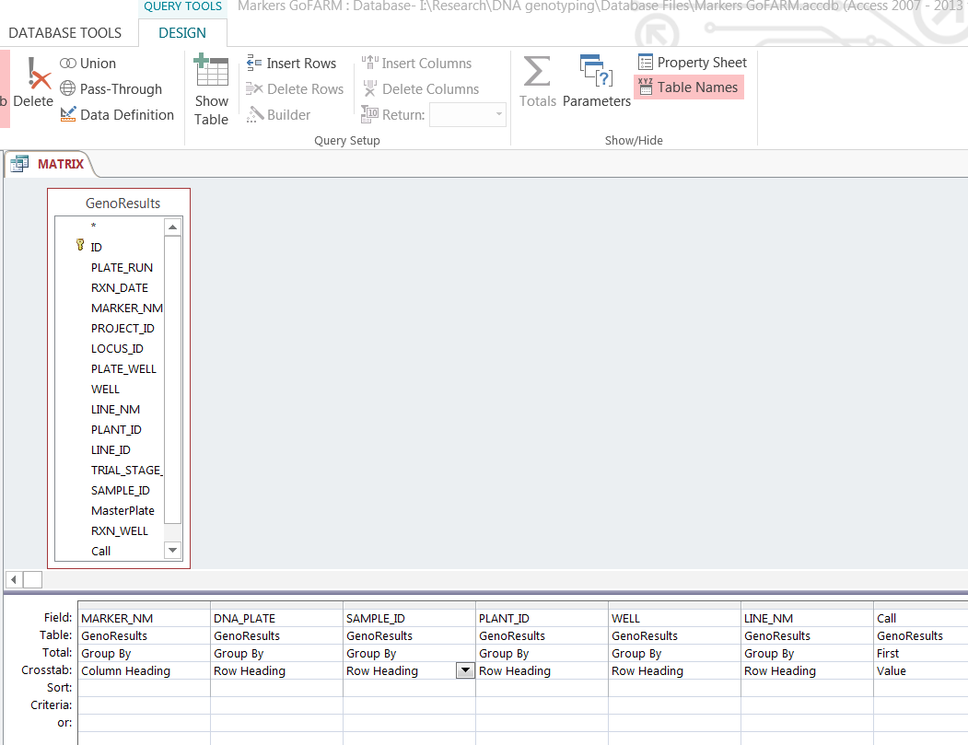
4. Export query as MATRIX.xlsx file
5. Open TemplatesMacro.xlsm
6. 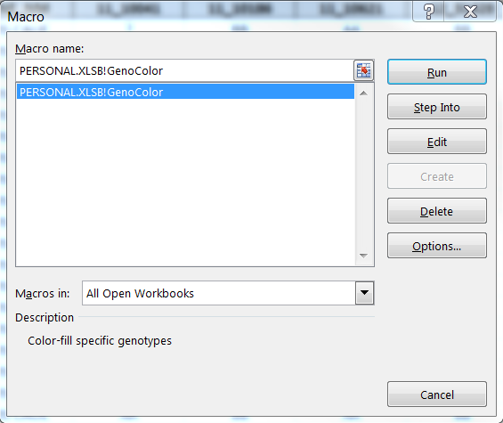In Excel MATRIX file, use TemplatesMacro.xlsm!GenoColor macro to assign genotype colors to cells with conditional formatting.
7. If this doesn’t work, copy and paste data into new excel file MATRIX2.xlsx.
8. Copy and paste Line profiles for the selected markers, in this case (11_10041, 11_10186, 11_10621 and 12_31428) above data set and add columns with concatenated genotype values adjacent to the Line Profiles and the data set. 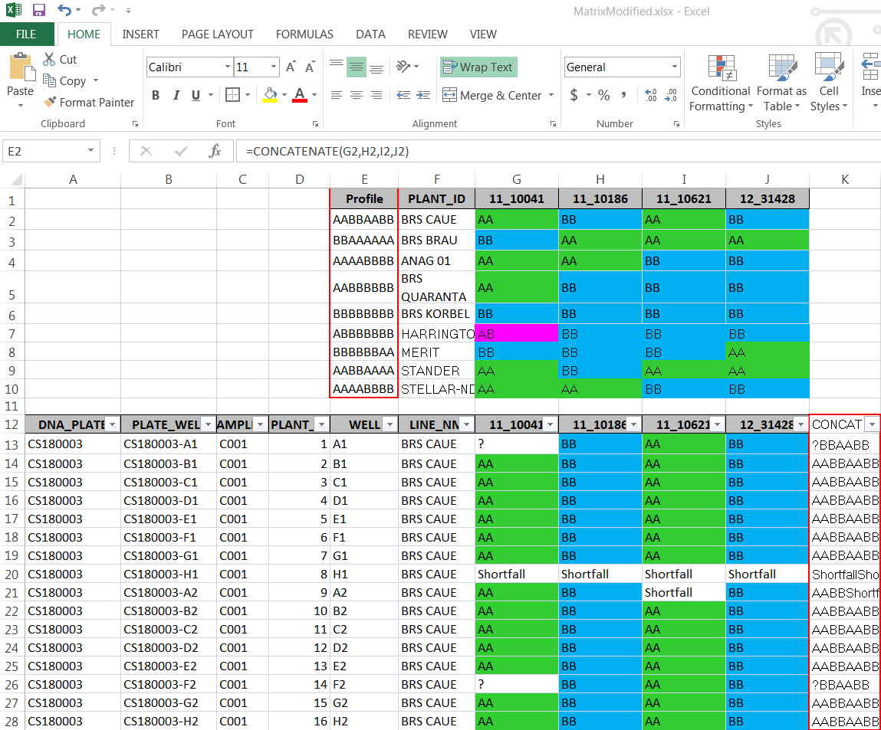
9. Use Vlookup function to find a match between the Sample concatenated genotype string and the Line Profile concatenated genotype string. 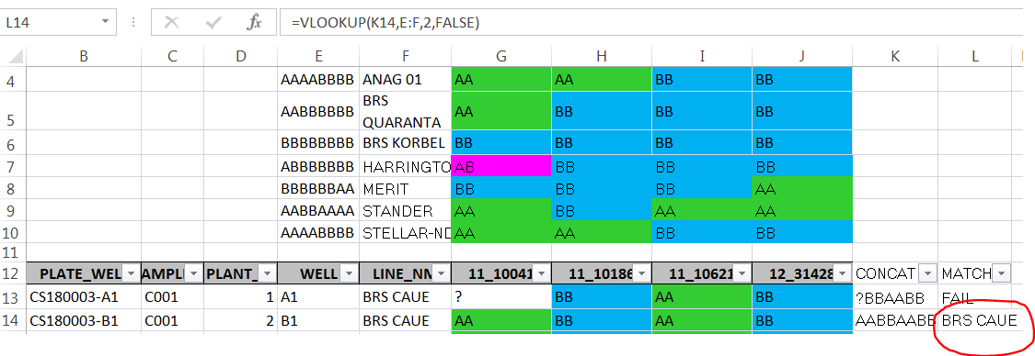
10. Visually asses data. If 25% or more of Markers for a single sample fail (Shortfall, Over or ?) the Match is manually entered as FAIL.
11. Use countif function to count matches from the Vlookup results for each line. Also count FAIL reactions. The cell locations of this formula must be adjusted for each set of samples. **This process is tedious and highly prone to human error**.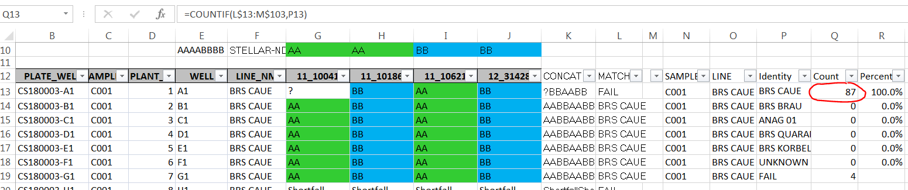
12. Use formula to create a percentage based on the Count/(#PLANT_ID - #FAIL)..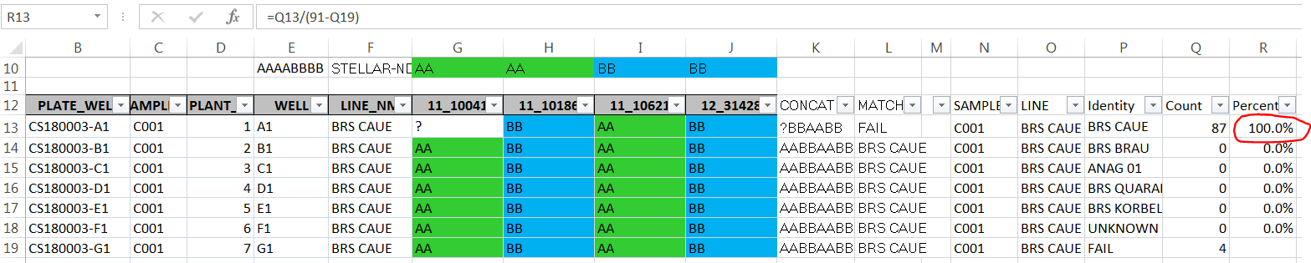
13. Using Filters, data can then be filtered by sample to summarize the results for each sample. 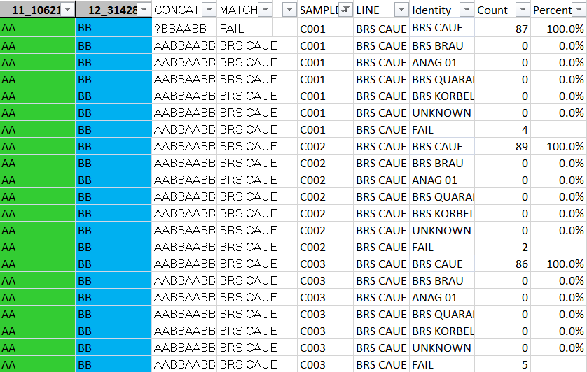
14. This information is then Copied and Pasted into a report table and 0% values removed (See REPORT.xlsx). 